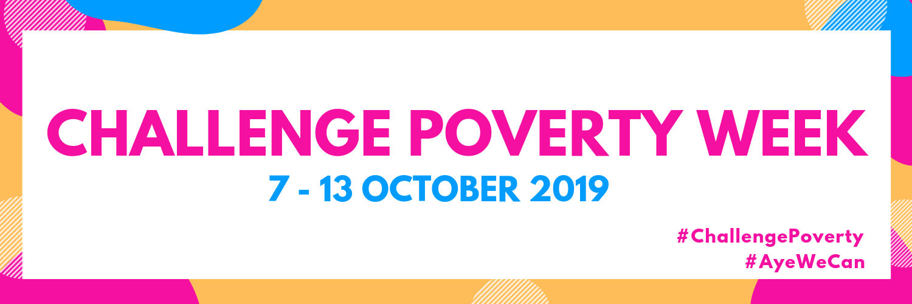

Pupil Debate Monday 7th October 2019

City Chambers Debating Chamber

Challenge Poverty Week was a chance for Glasgow City Council to bring together our young people from across our Educational establishments and look at the kind of society we want to live in and how poverty affects our local communities. To encourage debate and discussion we asked two questions;

1. How do you see poverty affecting young people in your local community?
2. How do you think we can best solve poverty together in Glasgow?

**Question 1. How do you see poverty affecting young people in your local community?**

**Pupils;**

* Social Exclusion, people missing out on opportunities due to lack of resources/money, like school trips, social events and non-uniform days.
* Poorer Health, causing more absences at school.
* Drugs and Alcohol abuse, a lack of role models, lack of motivation and this leads to growing up with low aspiration of what you can achieve.
* People being dependant on welfare or social security benefits.
* Not being able to afford to pay the rent or buy food.
* Young people being left out as they can`t afford to buy the right brand of clothes or shoes.
* Self-doubt and feeling left out
* Non uniform days, can cause you to stay away from school as it can be embarrassing if you don`t have the right clothes.
* Criminal activities increase as people can`t afford to pay for clubs etc. and young people get bored with nothing to do.
* Need to leave school early to get a job and help your family financially.

**Q2. How do you think we can best solve poverty together in Glasgow?**

**Pupils:**

* Increase the Modern Apprenticeship Minimum Wage
* Provide free school trips and resources at school, like pens, books etc.
* Universal free school meals for all as this will eliminate the stigma
* Donate to a food bank or a charity
* Employers need to pay more like the Glasgow Living Wage
* Provide free breakfast in schools
* Reduce Transport costs as they are too expensive
* Designated time on a one to one basis with teacher to discuss how you are
* Mentors provided for everyone at school at all ages
* More welfare or social security support for those experiencing poverty
* Support and child care for lone parents

At the end of the debate, the pupils were asked to tell us what one thing they would change more than anything else and the most common comments:

* Further support needed in terms of building confidence and self-belief
* Support in terms of budgeting/saving/advice on financial wellbeing
* More encouragement and info on alternative destinations other than university.

**Other comments made listed below;**

1. Ant-stigma training/poverty awareness sessions for all pupils and teachers.
2. Scheduled 1-2-1 talks every month with pastoral care.
3. Free Travel for young people at school.
4. Information on support available in school with the cost of school trips.
5. Youth Clubs, promote what is available in local areas.
6. Provide a discount or free access for young people to use sports or youth clubs.
7. Increase the minimum wage for young people 16/17.
8. Support in school, for example counselling.
9. Provide facilities to wash your clothes at school.
10. Abolish non uniform days.
11. Teach about confidence building.
12. Teach about life skills and money management skills.
13. Provide pupils with the confidence that they can still be successful even if they are not academic.
14. Period Poverty is a major issue for girls and this can affect girls participating in activities outside of school.
15. Make it normal to talk about poverty.