|  |
| --- |
| Workforce of the Future - Succession and Career Planning Framework |

Our Commitment

We are committed to supporting the development of all our employees to be the best they can be and we recognise that our employees are key to our continued success in achieving the priorities set out in the [Council's strategic plan 2017 -2022](https://www.glasgow.gov.uk/strategicplan).

We know that with workforce challenges ahead we need to ensure our workforce is future ready, with the right people in the right place at the right time whilst managing the renewal landscape for the council.

To achieve this aim, our Succession and Career Planning Framework will strengthen the learning and development of all our employees within the organisation and support them in their current role and to be career ready for future roles which is vital to ensure we continue to achieve our future organisational aims.

About this Framework

Our framework provides a model of ‘good practice principles’ that provides a general method to help services develop and implement their own succession and career planning process that meets their operational and professional requirements.

The framework contains a selection of information, support and tools that can be used at each step. It should be used in conjunction with theestablished [Performance coaching and review process](http://connect.glasgow.gov.uk/article/13473/Performance-Coaching-and-Review-PCR), the [Employee Performance Improvement Framework](http://connect.glasgow.gov.uk/CHttpHandler.ashx?id=25292&p=0), the Organisational Development Team and engagement from our managers and employees.

Key Principles

* The Succession plan will ensure business continuity, be future focused, aligned to the organisation’s strategic plan and supported by the leadership team.
* The service will identify their business-critical posts and required skills, knowledge and competences required to deliver these.
* The service will communicate the succession planning process to all employees, ensure it is understood and is transparent at all stages in the process.
* All employees will have the opportunity to have a career conversation at their PCR to share their career and development interests.
* A range of flexible activities are available to support managers to identify and assess potential employees.
* The succession planning process will be objective, based on merit, fairness and respect.
* All employees will be supported with a personal learning and development action plan to aid them in their current role and/or be career ready for a future post.
* Service HR assisted by OD will support implementation of the framework within their own service.
* Service HR will report on the implementation and evaluation through their workforce planning process submissions.

Succession Planning supports Workforce Planning

The diagram shows the link between our workforce planning process and our succession planning process.

Through our strategic workforce planning process the organisation can develop relevant workforce planning initiatives that will meet the requirements of our gap analysis. Through our succession planning process, we can align these aims, ensuring our internal talent is engaged in driving their learning & development plans to fit the future organisational needs.

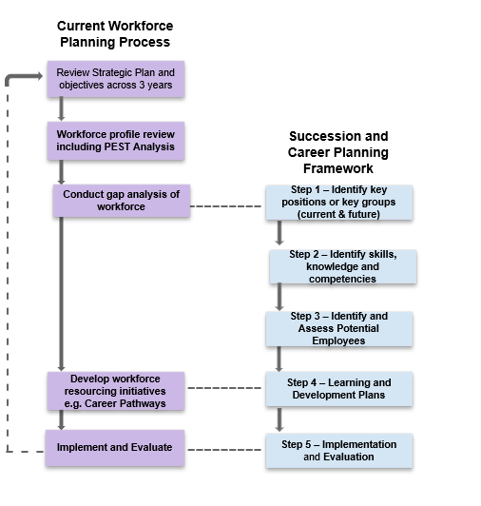

Succession and Career Planning Framework

The image below provides an overview of the Succession and Career Planning Framework and the activities that should be incorporated following service annual workforce planning submissions and incorporated within PCR milestones. It’s important to note that service implementation may operate at different times to meet specific arrangements.

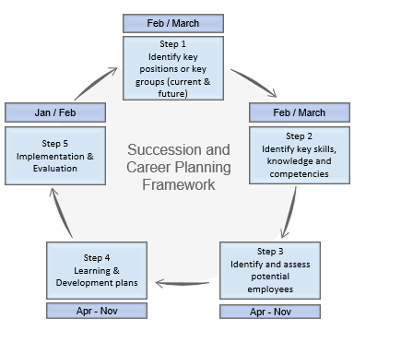

Step 1 – Identify Key Positions or Key Groups

This step requires the service to identify their posts to support the organisations sustainability and development across the following key areas:

* CMT / Leadership roles e.g. Leadership skills, behaviours and competencies.
* Managerial - Broad roles with future flexibility and generic skills e.g. stakeholder engagement, performance management, people management, project management, skills.
* Business critical and/or technically defined roles.

The roles should be identified across a two-part timeline :

* The first is the short-term plan to support immediate resourcing gaps for business-critical positions. This ensures that there is a business continuity plan in place that offers the organisation confidence and security in the event of the immediate loss of key employees.
* The second is the longer-term plan to develop career ready employees for future roles identified through workforce planning. This will ensure the organisation has the choice of competent applicants for key and critical roles in the future.

Step 2 – Identify Key Skills, Knowledge and Competencies

This step requires the service to identify the skills, knowledge and competency requirements of the key positions in their areas considering:

* What they need now to meet the immediate needs that arise.
* The future needs of the organisation, how will we be working, where and what will this mean for our workforce in terms of future skills, knowledge and competences required.
* Any planned workforce initiatives that might have an impact on the future workforce requirements for example: ageing workforce loss of skills, an organisational exit campaign.
* What the career path steps will be for each role to become competent. E.g. qualifications, evidence against required competencies, technical skills, etc.

To understand more about the required skills, knowledge and competencies you should use:

* [Job Families - Role profiles](http://connect.glasgow.gov.uk/article/11396/Job-Families)
* Person Specifications
* [Describing our competencies G1- G8](http://connect.glasgow.gov.uk/CHttpHandler.ashx?id=25531&p=0)
* [Describing our competencies - leadership G9-15](http://connect.glasgow.gov.uk/CHttpHandler.ashx?id=21171&p=0)
* Local management knowledge/experience

Step 3 – Identify and Assess Potential Employees

Service HR and OD will support managers to identify and assess potential employees as follows:

* Provide supporting guidance to managers on activities that can aid the process using the [Career and Succession Planning Conversation guidance](http://connect.glasgow.gov.uk/CHttpHandler.ashx?id=56858&p=0) and how to[Identify and Assess potential participants guidance.](http://connect.glasgow.gov.uk/CHttpHandler.ashx?id=56861&p=0)
* Identify ratings that will be applied through informal and formal assessment methods; this process will involve management assessment through the [PCR process](http://connect.glasgow.gov.uk/CHttpHandler.ashx?id=39565&p=0) and using the utilisation of the [9-box grid.](http://connect.glasgow.gov.uk/CHttpHandler.ashx?id=56724&p=0)
* Enable employees that are not identified in the immediate term to be potentially included later. PCRs will be reviewed every 6 months, as they consolidate learning and development within their current role.
* The[Critical Role Succession Plan](http://connect.glasgow.gov.uk/CHttpHandler.ashx?id=57540&p=0) will capture the key posts and the employees that have been identified as having potential. The service leadership team will agree the plan for submission to Head of HR and Finance.

Step 4 – Learning and Development Plan

* Each employee will have an individual learning and development action planto support them in their current role and to become future ready.
* This will consider the associated development, support required and timescales to be future ready.
* All skills, knowledge and competencies will have to be future proofed and flexible to ensure that it remains fit for purpose.
* Learning and development should be appropriate to the roles identified and meet the development needs of employees.

Step 5 – Implement and Evaluate Effectiveness

* To implement the framework the service must be clear of the strategic plan for the next 3–5 years to ensure employees are developed to meet the organisations priorities.
* Consider potential ER/VR campaigns and the terms and timing.
* Implementation must not be grade orientated and preclude anyone.
* The framework must be transparent and inclusive to ensure integrity is maintained and there are no ill feelings of a ‘talent club.’
* Evaluation of plans can take place every 6 months by the leadership team and adjusted to suit the emerging needs.
* Report on implementation and evaluation through the workforce planning process submissions.

**Key considerations for evaluation:**

* Have succession plans for all key positions been identified?
* Are business critical positions being filled quickly?
* Percent (%) of open positions filled by succession candidates
* The number of “Ready Now” employees within the succession planning process
* Are newly appointed “Ready Now” employees in key positions performing effectively?
* Impact proof learning and development interventions effectiveness – Are employees “Ready” to apply for key posts?
* Assessment of current and former skills gaps within the Service
* Is the employee pool diverse and reflective of equality?
* Ongoing analysis of the overall effectiveness of the Succession Planning Framework - identify areas of improvement

Governance

|  |  |
| --- | --- |
| **Workforce Resourcing Group** | * Lead on the implementation of the framework in their service. * Collaborate and support each other on the design of resourcing initiatives and succession plans to meet future workforce needs |
| **Service Leadership Team** | * Approve and sign off succession plan to ensure its aligned to support business continuity and future needs. |
| **CHR Leadership Team** | * CHR hold all service plans and share with Head of HR/Head of FS for noting WFP or budgetary impacts * Head of HR shares with Chief Executive as required * Produce organisational progress reports to CMT as required |

Role and Responsibilities

**Executive Directors** will ensure the principles of the Career and Succession Planning Framework are applied.

**Workforce Resourcing Group** are owners of the framework for their service. Theywill create joint service solutions working with OD on learning and development initiatives

**Employees** will share career and development interests to start to define development needs and participate in a range of activities to identify development needs and action plans.

**Line managers** will discuss with team members career and development interests utilising a range of activities to help identify development needs and plan.

**Corporate HR** will have overall responsibility to ensure that framework principles are being applied fairly and consistently.

**Organisational Development** will work with Services to support succession planning and career conversations with a range of learning and development initiatives.

**Service HR** will support on the implementation of the framework and work with OD on workforce resourcing initiatives and learning and development programmes.

Further Information and Support

[Council's Strategic Plan 2017 -2022](https://www.glasgow.gov.uk/strategicplan) sets out the priority themes and commitments that will be delivered over the next five years by the council, its services and arm's length organisations.

[Succession & Career Planning - GOLD Course](https://app.tessello.co.uk/gold/#/category/5179/*/resources/178373/succession-and-career-planning) this will provide you with an introductory understanding of Succession Planning.

[Employee Development](http://connect.glasgow.gov.uk/article/11256/Employee-Development) pages on Connect have information on a wide range of training and development opportunities, including e-learning courses on GOLD.

[Employee Performance Improvement Framework](http://connect.glasgow.gov.uk/CHttpHandler.ashx?id=25292&p=0) on Connect has a model of good practice principles that supports performance improvement across any role or service

[Recruitment and Selection Toolkit](http://connect.glasgow.gov.uk/article/11355/Recruitment-and-Selection-Toolkit) pages on Connecthave information**,** guidance and resources to support the recruitment and selection procedure, role profiles, competencies and pay and grading information.

[Redeployment Information and Guidance](http://connect.glasgow.gov.uk/article/14242/Redeployment-Guidance-and-Information) pages on Connect have information on redeployment support, career pathways and case studies on employee who have developed their career.